# Experimental Report

## CP1N6-24721015 李鹏麒

# **所属内容：Experimental N6-C1-20241204**

# **完成部分说明：编写算法与代码、调试与测试、撰写实验报告**

**The programme language**: C language

**The programming platform**: Visual Studio Code

**Program function**:

1. Input the scores of m courses of n students from the keyboard.

2) Calculate the average score of each student, the highest and the lowest score.

3) Count the number of students with more than 85 points and failed in each course.

4) The results calculated above are displayed in the form of a table and require calling custom functions written to draw table lines.

**Program algorithm**:(Specific code is in the folder)

First define a structure for students’ data including scores, average, lowest, highest, above, and failed. Then define functions with the ability of inputting scores from the user, calculating each student's average, highest, and lowest scores, counting students scoring above 85 and those who failed each course with the use of pointer variables. Finally display the results in a table format using a custom function to draw lines.

**Program flow chart:**

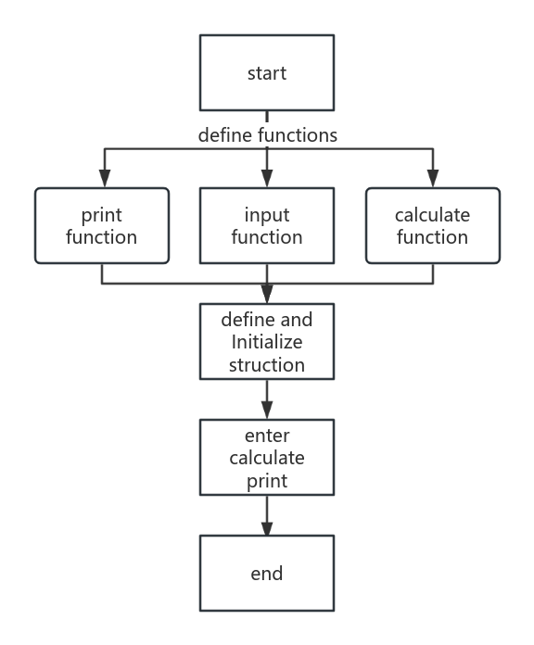

**Program experiment test:**

